### 5th August 2016

### YOKOHAMA Launches Sales of New High-Pressure Hydrogen Gas Hose, “ibar HG82”

Tokyo – Yokohama Rubber Co., Ltd., announced today that from early August 2016 it will begin sales of “ibar HG82,” a new high-pressure hydrogen gas hose developed in cooperation with Iwatani Industrial Gases Corp. The new hydrogen dispenser hose is to be used for filling fuel cell vehicles (FCVs) with hydrogen. The hose is compatible for use in hydrogen gas filling stations complying with recent regulatory changes that approved use of compressors capable of 82Mpa dispensing pressure. The hose’s other special features include light weight and excellent flexibility, which facilitate transportation of the hoses and their use in the hydrogen filling process. Yokohama Rubber expects the “ibar HG82" to contribute to the spread of hydrogen filling stations, a key component in plans to increase the number of FCVs on the road in Japan and abroad. As of end-June 2016, Japan had a total of 77 hydrogen filling stations, but the number of stations is expected to expand in Japan and abroad in the years ahead.

The “ibar HG82” is based on technologies acquired during the development of its predecessor hose, the “ibar HG70”. The use of a hybrid structure combining fibre and steel wire results in a lighter, more flexible hose capable of use with high-pressure dispensing. The hybrid structure also increases the hose’s durability. Using knowledge gained in evaluations to date, YOKOHAMA has developed a proprietary hose evaluation test method based on simulations of the actual application environment at hydrogen filling stations. The result is a safer-to-use, high-pressure hydrogen gas hose.

YOKOHAMA developed its first hydrogen dispensing hose, the “ibar HG35”, compatible with dispensing pressure of 35MPa, in 2006. In 2010, the Company developed the “ibar HG70,” capable of dispensing hydrogen at 70MPa. Since 2013, Yokohama Rubber has been working on the development of high-pressure hoses in a project* commissioned by Japan’s New Energy and Industrial Technology Development Organization (NEDO). In line with Japan's plans to raise hydrogen filling stations to the international standard 87.5MPa, YOKOHAMA’s development team is currently engaged in the development of an 87.5MPa-compatible hose.

* Hydrogen Technology Research and Development Project / R&D of low-cost equipment and systems, etc., for use in FCVs and hydrogen filling stations / R&D on high-pressure hoses and sealing system for use in hydrogen filling stations.

***[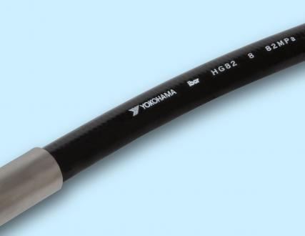](https://www.y-yokohama.com/release/download/download.php?no=2677&lang=en)***

***[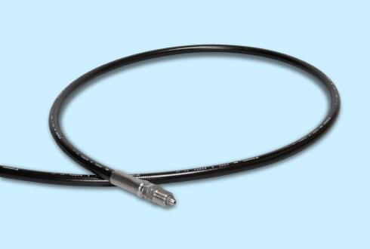](https://www.y-yokohama.com/release/download/download.php?no=2677&lang=en)***

***ibar HG82***